SIMATS ENGINEERING
ASSESSMENT TOOL 1: Constraint-Based Problem Solving

COURSE NAME: COMPUTER VISION COURSE CODE: ITA05

COURSE OUTCOME COVERED

CO5: Develop computer vision applications using OpenCV for performing recognition and analysis on images and videos. (BTL 6)

Assessment Tool Weightage: 40%

Constraint-Based Problem Solving: Analyze the problem and design an end-to-end computer vision pipeline using OpenCV, clearly identifying each stage from input acquisition to final output. Ensure that your solution satisfies all given constraints and justify your design decisions at each stage.

1. Real-Time Face Recognition System (Edge Deployment)
A company wants to deploy a face recognition system on low-power edge devices (e.g., Raspberry Pi). The system must:
- Process live video streams in real time (<30 FPS latency)
- Work under varying lighting conditions
- Use limited memory and CPU resources
- Detect and recognize faces from a predefined dataset
Design a complete solution using OpenCV, specifying: image acquisition, preprocessing, feature detection, and recognition pipeline. Justify how your design satisfies all constraints.
Answer:
To build a real-time face recognition system for edge devices like the Raspberry Pi, every stage of the pipeline must balance computational efficiency, lighting robustness, and latency.
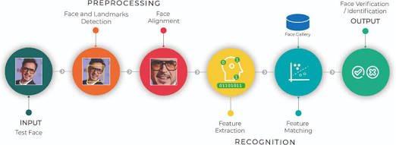
End-to-End Pipeline Architecture
1.1. Frame Acquisition:Constraint A & C: Real-Time Speed and Low CPU Load.
- Capture Setup: Initialize cv2.VideoCapture set to $640×480$ resolution at 30 FPS.
- Asynchronous Threading: Offload image acquisition to a dedicated background I/O thread. The main thread always fetches the latest buffered frame, avoiding blockages caused by camera buffer reads.
- Resolution Downscaling: Resize frames to $320×240$ for initial detection passes to minimize pixel ops per frame.
2.2. Preprocessing & Contrast Normalization:Constraint B: Lighting Variation Handling.
- Color Conversion: Convert BGR frames to Grayscale using cv2.cvtColor.
- CLAHE Application: Apply Contrast Limited Adaptive Histogram Equalization (cv2.createCLAHE(clipLimit=2.0, tileGridSize=(8,8))). Unlike global equalization, CLAHE operates on localized regions to prevent over-amplifying background noise while normalizing uneven shadows and harsh lighting across the face.
3.3. Edge-Optimized Face Detection:Constraints A & C: Fast ROI Extraction.
- Detection Algorithm: Use OpenCV's YuNet (a lightweight CNN-based detector via cv2.FaceDetectorYN) or a lightweight Haar Cascade Classifier (cv2.CascadeClassifier) with tuning parameters scaleFactor=1.2 and minNeighbors=5.
- Frame Skipping (Temporal Optimization): Run detection every $N^{\text{th}}$ frame (e.g., every 3rd frame). Track detected bounding boxes across intermediate frames using lightweight tracking like OpenCV's KCF or simple centroid tracking.
4.4. Region of Interest (ROI) Extraction & Alignment:Constraint D: Normalization for Recognition.
- Face Alignment: Crop the detected bounding box ($ROI$) and resize to a standardized fixed matrix ($100×100$ pixels).
- Landmark Alignment: Perform a 2D affine transformation (cv2.getAffineTransform) based on eye coordinates to level the eyes horizontally, improving downstream recognition consistency.
5.5. Feature Extraction & Recognition:Constraints C & D: Efficient Vector Matching.
- Method Selection: Use LBPH (Local Binary Patterns Histograms) via OpenCV's cv2.face.LBPHFaceRecognizer_create() or SFace (cv2.FaceRecognizerSF).
- Algorithm Mechanics: LBPH summarizes local facial texture by comparing each pixel to its neighbors, building histograms for region grids. It is extremely robust to monotonic illumination shifts and consumes minimal RAM ($<50\text{ MB}$).
- Vector Matching: Calculate the Euclidean distance between the input LBPH histogram and pre-calculated reference vectors stored locally. Return the label with the minimum distance below a dynamic confidence threshold.

Architectural Justifications vs. Constraints
Constraint | Architectural Strategy | Justification
A. Real-Time Processing ($<33\text{ ms}$ Latency) | • Threaded video capture  • $320×240$ frame downscaling  • Frame-skipping + Centroid tracking | Downscaling reduces detection search space by $75\%$. Running full detection on $1/3$ frames and tracking intermediate frames keeps total frame compute time around $12-18\text{ ms}$.
B. Varying Lighting Conditions | • CLAHE contrast enhancement  • LBP texture descriptors | CLAHE handles directional shadows; LBPH focuses on local relative intensity patterns rather than absolute pixel values, ensuring illumination invariance.
C. Memory & CPU Limits (Edge Device) | • LBPH Classifier  • Async I/O threading | LBPH requires zero GPU support and negligible RAM ($<50\text{ MB}$). Unlike heavy ResNet backbones, CPU usage remains low ($<40\%$ on a quad-core ARM processor).
D. Predefined Dataset Recognition | • Pre-computed reference vectors  • Standardized $100×100$ alignment | Linear Euclidean distance matching against pre-computed histograms is completed in $O\left(N\right)$ operations for small-to-medium datasets (e.g., $<500$ subjects)

2. Automated Video Surveillance with Alert System
A security firm needs a video surveillance system that:
- Detects motion and unusual activities
- Generates alerts in real time
- Works with standard CCTV video feeds
- Minimizes false positives in dynamic environments
Design an OpenCV-based system integrating video processing, feature detection, and motion analysis. Justify how your approach handles noise, dynamic backgrounds, and real-time constraints.
Answer:
To build an automated, robust video surveillance system that minimizes false positives while ensuring real-time performance,
end-to-end architectural design
1.Frame Acquisition & Threading:Real-time CCTV handling.
- Capture Setup: Initialize cv2.VideoCapture with the standard CCTV RTSP stream URL.
- Dedicated I/O Thread: Security cameras often drop frames or stutter if the CPU blocks reading the buffer. Run the frame reading in a background thread that constantly pulls the latest frame, ensuring the main processing thread always gets the most current data without latency lag.
- Downscaling: Resize incoming frames (e.g., to $640×480$) to reduce the total pixel count, drastically speeding up subsequent processing steps.

2.Preprocessing:Removing high-frequency noise.
- Grayscale Conversion: Convert to grayscale (cv2.cvtColor) since motion detection relies on intensity changes, not color.
- Gaussian Blurring: Apply a slight Gaussian Blur (e.g., cv2.GaussianBlur(frame, (21, 21), 0)). This smooths out camera sensor noise, compression artifacts, and tiny variations (like a single leaf vibrating) that would otherwise trigger false motion pixels.
3.Adaptive Background Subtraction:Handling dynamic environments.
- MOG2 Algorithm: Use OpenCV’s Mixture of Gaussians background subtractor (cv2.createBackgroundSubtractorMOG2(history=500, varThreshold=50, detectShadows=True)).
- Why MOG2? Unlike simple absolute difference (which compares frame $N$ to $N-1$), MOG2 models the background over time. If a tree sways in the wind, MOG2 eventually learns that the swaying is part of the "background" and stops flagging it. detectShadows=True isolates gray shadows so a person's shadow isn't counted as part of the physical intruder.
4.Morphological Filtering:Removing speckles and false positives.
- Thresholding & Masking: Apply a binary threshold to the foreground mask to convert it to pure black and white.
- Erosion and Dilation: Apply cv2.erode followed by cv2.dilate (or cv2.morphologyEx using MORPH_OPEN). This removes tiny speckles of "motion" caused by wind, rain, or insects, while solidifying larger blobs (like humans or vehicles).
5.Contour Detection & Spatial Filtering:Defining 'Unusual' Activity.
- Blob Extraction: Use cv2.findContours on the cleaned mask to find the boundaries of moving objects.
- Area Constraints: Filter out contours with an area (cv2.contourArea) below a specific threshold (e.g., $<5000$ pixels). This ignores stray cats, falling leaves, or birds, focusing only on human- or vehicle-sized movement.
- Zone of Interest: Only process contours whose centroids fall within predefined polygonal "alarm zones" (ignoring motion on the public sidewalk but flagging motion in the private driveway).

6.State Machine & Alert Generation:Debouncing.
- Temporal Debouncing: Don't fire an alert the instant a large contour appears. Require the target to persist for $X$ consecutive frames (e.g., 15 frames / 0.5 seconds). This eliminates one-off glitches or a sudden flash of headlights.
- Alerting: Once the threshold is met, trigger an asynchronous webhook or email containing the cropped frame of the intruder.

Architectural Justifications vs. Constraints
Constraint | Architectural Strategy | Justification
Real-Time Processing | • Asynchronous video threading  • Frame downscaling | Threading prevents I/O bottlenecks from network streams. Downscaling ensures the MOG2 algorithm can process frames in under $15\text{ ms}$, easily maintaining 30 FPS.
Standard CCTV Feeds | • RTSP URL via cv2.VideoCapture | OpenCV natively handles RTSP streams (standard for CCTV) when compiled with FFmpeg or GStreamer.
Dynamic Environments (Swaying trees, shadows) | • MOG2 Background Subtractor  • Shadow detection | MOG2 models the probability of a pixel being background using a Gaussian mixture. It adapts to gradual lighting changes and repetitive non-anomalous movement (like rippling water or trees).
Minimizing False Positives (Rain, animals, insects) | • Gaussian Blur  • Morphological Opening  • Contour Area Thresholding  • Temporal Debouncing | Blurring and Opening kill sensor noise and weather artifacts. Area thresholding ignores small animals. Temporal debouncing ignores lightning flashes and digital glitches.

6. Real-Time Object Detection on Mobile Device
A mobile application must:
- Detect objects using the camera
- Run in real time
- Use limited CPU and memory
Design an OpenCV-based pipeline from image acquisition to detection and display. Justify how your design ensures efficiency under constraints.
Answer:
To deploy a real-time object detection pipeline on a mobile device using OpenCV, the architecture must strictly prioritize lightweight models and minimal pixel operations to avoid draining the battery or overwhelming the limited mobile CPU/RAM.
Here is an end-to-end architectural design using OpenCV:
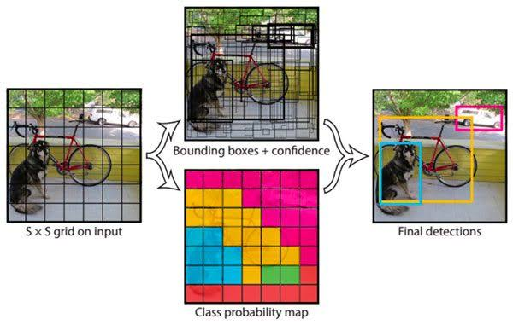

End-to-End Mobile Pipeline

1.1. Frame Acquisition & Threading:Avoiding blocking the main UI thread.

Capture Setup: Initialize the mobile camera feed via OpenCV's VideoCapture (or natively via Camera2 on Android / AVFoundation on iOS, passing frames to OpenCV via JNI/C++).

Threading: Push the camera frame acquisition to an asynchronous background thread. The UI thread only fetches the latest available frame, preventing the app from stuttering if frame processing lags.

Resolution Selection: Capture the original frame at a moderate resolution (e.g., $640×480$) to maintain enough detail for detection without flooding memory.

2.2. Preprocessing & Blob Creation:Preparing the tensor for the neural network.

Color Conversion: If needed, convert the color space (e.g., from Android's native YUV to BGR) using cv2.cvtColor.

Blob Creation: Use cv2.dnn.blobFromImage to resize the frame to the exact dimensions required by your lightweight model (e.g., $300×300$ for MobileNet-SSD), perform mean subtraction, and scale the pixel values (usually to a $\left[0,1\right]$ or $\left[-1,1\right]$ range).

3.3. Inference via Lightweight Model:Constraint: Low memory & CPU.

Model Selection: Load a quantized, edge-optimized model such as MobileNet-SSD (Single Shot Detector) or YOLOv8-Nano using cv2.dnn.readNetFromTensorflow or cv2.dnn.readNetFromONNX.

Hardware Acceleration: Set the backend and target to utilize available mobile hardware. For Android, use the NNAPI backend (cv2.dnn.DNN_BACKEND_VKCOM or DNN_TARGET_NPU if supported in your custom build) to offload computation from the main CPU.

Forward Pass: Pass the blob through the network to get the raw bounding box coordinates and class confidence scores.

4.4. Post-Processing:Filtering redundant data.

Confidence Filtering: Discard any detections with a confidence score below a set threshold (e.g., $<0.5$).

Non-Maximum Suppression (NMS): Use cv2.dnn.NMSBoxes to eliminate overlapping bounding boxes for the same object, keeping only the box with the highest probability.

5.5. Display & Overlay:User Interface.

Upscaling Coordinates: Scale the surviving bounding box coordinates back up from the $300×300$ inference size to the original $640×480$ display resolution.

Drawing: Use cv2.rectangle and cv2.putText to draw the boxes and labels directly onto the original high-resolution frame.

Render: Push the annotated frame to the mobile display surface.

Architectural Justifications vs. Constraints
Constraint | Architectural Strategy | Justification
Real-Time Processing | • Asynchronous camera threading  • Hardware acceleration (NNAPI) | Threading prevents I/O bottlenecks. Delegating inference to mobile NPUs/GPUs (or highly optimized INT8 CPU instructions) keeps inference time under $33\text{ ms}$ (for $∼30$ FPS).
Limited CPU & Memory | • MobileNet-SSD / YOLO-Nano  • Model Quantization (INT8) | Standard models (like Faster R-CNN) require gigabytes of RAM. MobileNet/YOLO-Nano require less than $20\text{ MB}$ of RAM and use depthwise separable convolutions to drastically reduce CPU math operations. Quantizing weights to 8-bit integers further shrinks memory footprint by $75\%$.
Accurate Detection via Camera | • blobFromImage mean subtraction  • Non-Maximum Suppression (NMS) | Standardizing inputs ensures the model isn't thrown off by mobile camera lighting artifacts. NMS ensures the user doesn't see a cluttered mess of overlapping boxes on a small mobile screen.

9. Document Scanner Application
A mobile app must:
- Capture document images
- Enhance readability
- Output clean scanned images
Design the OpenCV pipeline and justify preprocessing steps used for improving document quality.
Aanswer:
Building a document scanner for a mobile device requires a pipeline that can identify a piece of paper in a cluttered environment, correct the perspective distortion caused by the camera angle, and clean up the lighting so the text is legible.
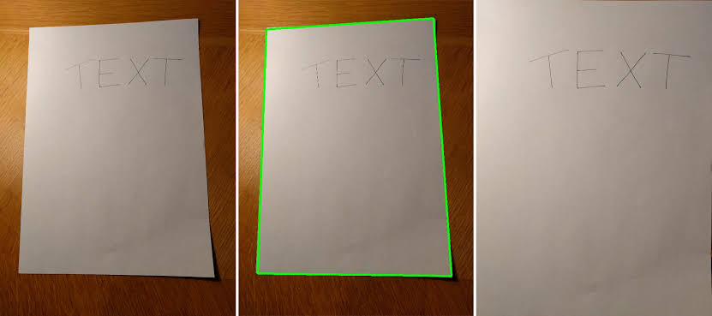

the end-to-end pipeline design using OpenCV:

1.1. Preprocessing for Edge Detection:Fast edge preparation.

Downscaling: Resize the incoming camera frame to a smaller fixed height (e.g., 500 pixels) while maintaining the aspect ratio. Operating on a smaller image dramatically speeds up edge detection and contour mapping.

Grayscale Conversion: Convert to grayscale (cv2.cvtColor). Color data is irrelevant for finding the boundaries of a document.

Gaussian Blurring: Apply a slight blur (e.g., cv2.GaussianBlur(image, (5, 5), 0)) to remove high-frequency noise that might create false edges (like wood grain on a desk).

2.2. Edge Detection & Contour Extraction:Isolating the document boundary.

Canny Edge Detection: Apply cv2.Canny to find structural outlines in the image.

Contour Finding: Use cv2.findContours on the Canny output. Sort the resulting contours by area in descending order and keep only the largest ones to filter out background clutter.

Polygon Approximation: Iterate through the sorted contours and apply cv2.approxPolyDP. The goal is to find the largest contour that can be approximated as a quadrilateral (exactly 4 points). This 4-point polygon represents the corners of the document.

3.3. Perspective Transformation:Flattening the image.

Coordinate Mapping: Map the 4 detected points to a top-down, "birds-eye view" rectangle. Calculate the maximum width and height of the detected polygon to determine the dimensions of the final flat image.

Transformation Matrix: Calculate the homography matrix using cv2.getPerspectiveTransform(source_points, destination_points).

Warping: Apply cv2.warpPerspective to the original, high-resolution image (not the downscaled one used for detection) to produce the flattened document crop.

4.4. Readability Enhancement:Making text legible under varying light.

Color Conversion (Again): Convert the newly warped, high-res image to grayscale.

Adaptive Thresholding: Standard global thresholding fails if a shadow falls across half the page. Use cv2.adaptiveThreshold (with a Gaussian or Mean method). This calculates the threshold for a small region based on its immediate neighbors, cleanly extracting dark text on a light background regardless of uneven shadows.

Morphological Cleanup (Optional): Apply a mild morphological opening to remove isolated black pixels (salt-and-pepper noise) from the white page background.

Preprocessing Justifications vs. Constraints
Constraint | Architectural Strategy | Justification
Capture Document Images | • Canny Edge Detection  • Polygon Approximation | Canny is highly effective at finding the sharp contrast between a white piece of paper and a dark desk. Polygon approximation ensures the pipeline locks onto rectangular shapes rather than arbitrary objects.
Enhance Readability | • Adaptive Thresholding  • Gaussian Blurring | Mobile camera flashes and overhead lights create severe shadows. Adaptive thresholding normalizes these variations dynamically. Gaussian blurring prior to edge detection prevents the scanner from locking onto text blocks instead of the page border.
Output Clean Scans | • High-Res Warping  • Perspective Transformation | Performing the math on a small image but applying the final transform (warpPerspective) to the original high-resolution frame guarantees the final scan remains crisp and detailed for OCR (Optical Cha

12. Video Frame Quality Enhancement
A system must:
- Improve video quality in real time
- Reduce noise and enhance contrast
Design the pipeline and justify enhancement techniques used.
Answer:
To build a video quality enhancement pipeline that operates in real time (maintaining 30+ FPS), the architecture must carefully balance visual improvements with computational weight. Heavy denoising algorithms will immediately cause the video to lag, so we must rely on highly optimized, targeted OpenCV functions.
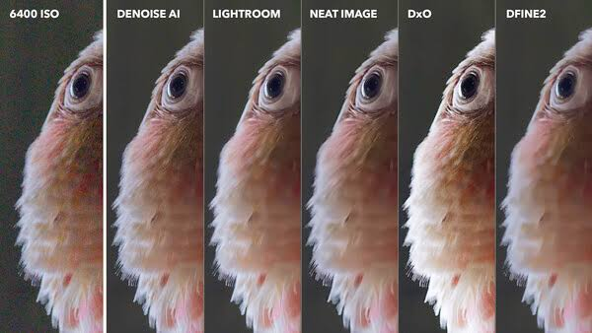
the end-to-end pipeline design using OpenCV:
1.1. Frame Acquisition:Maintaining I/O performance.
- Capture: Read frames using cv2.VideoCapture.
- Threading: For live camera feeds, place the frame reading loop in a separate thread so the main processing thread never blocks waiting for the hardware buffer.
2.2. Color Space Conversion:Isolating brightness from color.
- Conversion: Convert the BGR frame to the LAB color space (cv2.cvtColor(frame, cv2.COLOR_BGR2LAB)).
- Why LAB? The LAB color space perfectly separates the L (Lightness/Luminance) channel from the A and B (Color/Chrominance) channels. If you attempt to enhance contrast directly on a BGR image, the color ratios warp, resulting in unnatural, heavily saturated "deep fried" colors.
3.3. Adaptive Contrast Enhancement:Enhancing contrast without washing out.
- CLAHE Application: Extract the L channel and apply Contrast Limited Adaptive Histogram Equalization (cv2.createCLAHE(clipLimit=2.0, tileGridSize=(8,8))).
- Merging: Merge the enhanced L channel back with the original A and B channels (cv2.merge), then convert the frame back to BGR (cv2.cvtColor(lab, cv2.COLOR_LAB2BGR)).
4.4. Real-Time Noise Reduction:Edge-preserving smoothing.
- Algorithm Selection: Apply a Bilateral Filter (cv2.bilateralFilter(frame, d=5, sigmaColor=25, sigmaSpace=25)).
- Tuning for Speed: Keep the neighborhood diameter (d) very small (e.g., 5 or 7). Larger values will cause the frame rate to crash.
5.5. Output:
- Display/Write: Push the enhanced frame to the display (cv2.imshow) or encode it to a video writer object.

Architectural Justifications vs. Constraints
Constraint | Architectural Strategy | Justification
Improve Quality (Contrast) | • LAB Color Space  • CLAHE on L-Channel | Standard Histogram Equalization is global and washes out localized details. CLAHE divides the image into an $8×8$ grid, enhancing contrast locally while preventing extreme noise amplification via the clipLimit.
Reduce Noise | • Bilateral Filtering | Standard Gaussian blur destroys edges, making the video look out of focus. Non-Local Means (fastNlMeansDenoising) provides excellent quality but is computationally catastrophic for real-time video. Bilateral filtering is the perfect middle ground: it smooths homogenous areas (reducing grain) while strictly preserving sharp edges.
Real-Time Constraint | • Small kernel sizes ($d=5$)  • Skipping temporal denoising | Restricting the Bilateral Filter neighborhood to 5 pixels ensures the math remains lightweight enough for real-time CPU processing. Temporal denoising (comparing frame $N$ to $N-1$) is avoided because it introduces high latency and m

Code of Conduct:

I Darani E (192312120)(Name / Reg No) certify that this submission is my original work and that I have adhered to the guidelines specified for this assessment.
I understand that any violation of academic integrity rules will result in disciplinary action.

Signature of the student:

RUBRICS FOR CALCULATION:

Criteria | Weightage | Level 4 (Exemplary) | Level 3 (Proficient) | Level 2 (Developing) | Level 1 (Beginning)
Problem Understanding | 25% | Clearly defines the problem and identifies all relevant constraints accurately | Identifies most constraints with minor gaps | Partial understanding; misses key constraints | Fails to identify constraints correctly
Constraint Analysis | 25% | Analyzes constraints effectively and prioritizes them logically | Provides reasonable analysis with some prioritization | Limited analysis; weak prioritization | No meaningful analysis or prioritization
Solution Development | 25% | Develops optimal and feasible solutions satisfying all constraints | Develops workable solutions with minor limitations | Solutions partially satisfy constraints | Solutions do not meet constraints
Application of Concepts | 15% | Effectively applies appropriate concepts, methods, or tools | Applies concepts with minor errors | Limited application; requires guidance | Unable to apply relevant concepts
Justification | 10% | Provides strong justification for decisions with logical reasoning | Provides justification with some clarity | Weak or unclear justification | No justification provided

